# Course 2 Tools of Data Science – Week 2

## Overview of Git and GitHub

Git and GitHub are tools for version control.

What is Version contro?

A version control system allows you to keep track of changes to your documents. This makes it easy for you to recover older versions of your document if you make a mistake, and it makes collaboration with others much easier.

Below is a basic example:

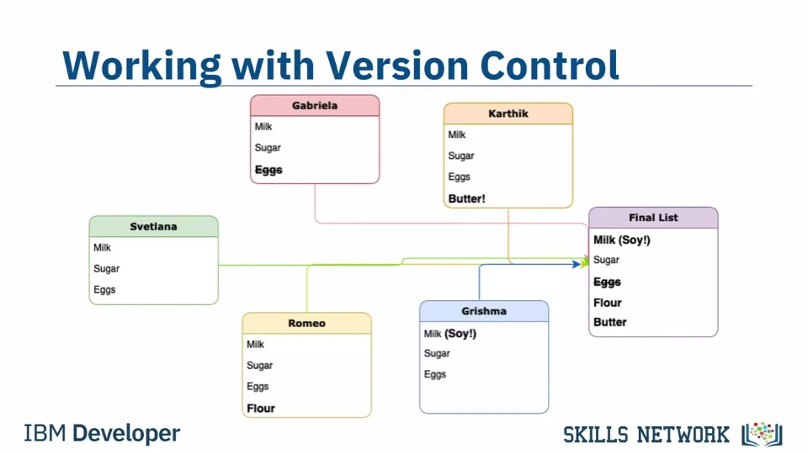

**About Git:**

* It is a free and open source system
* One of the most popular version control tools
* It a distributed version system
* Accessible world wide
* Changes are seen in real time (via a remote server)

It is usually used for code, but you can also share images and documents

You can use Git without a web interface by using your command line interface

**GitHub**: a platform for hosting and collaborating on Git repositories - one of the most popular web-hosted services for Git repositories

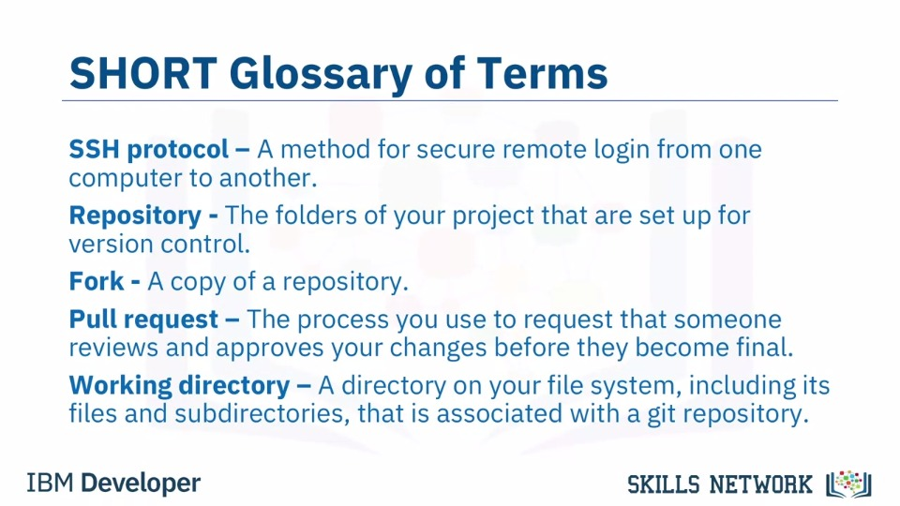

**Basic Commands of Git**

When starting out with a new repository, you only need create it once: either locally, and then push to GitHub, or by cloning an existing repository by using the command "**git init".**

**"git add"** moves changes from the working directory to the staging area.

**"git status"** allows you to see the state of your working directory and the staged snapshot

of your changes.

**"git commit"** takes your staged snapshot of changes and commits them to the project.

**"git reset"** undoes changes that you’ve made to the files in your working directory.

**"git log"** enables you to browse previous changes to a project.

**"git branch"** lets you create an isolated environment within your repository to make changes.

**"git checkout"** lets you see and change existing branches.

**"git merge"** lets you put everything back together again.